1. download Flash Download Too
2. <https://www.espressif.com/sites/default/files/tools/flash_download_tool_v3.8.5.zip>
3. Extract downloaded folder
4. Open folder, open “flash_download_tool_3.8.5.exe”

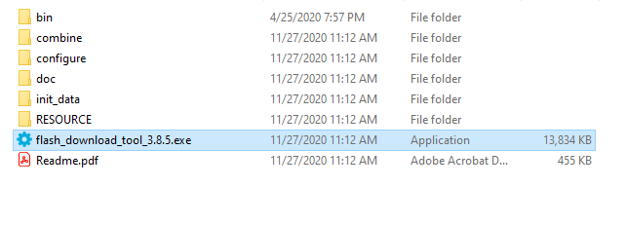

1. Two Windows popup. Select “Developer Mode” in the grey window

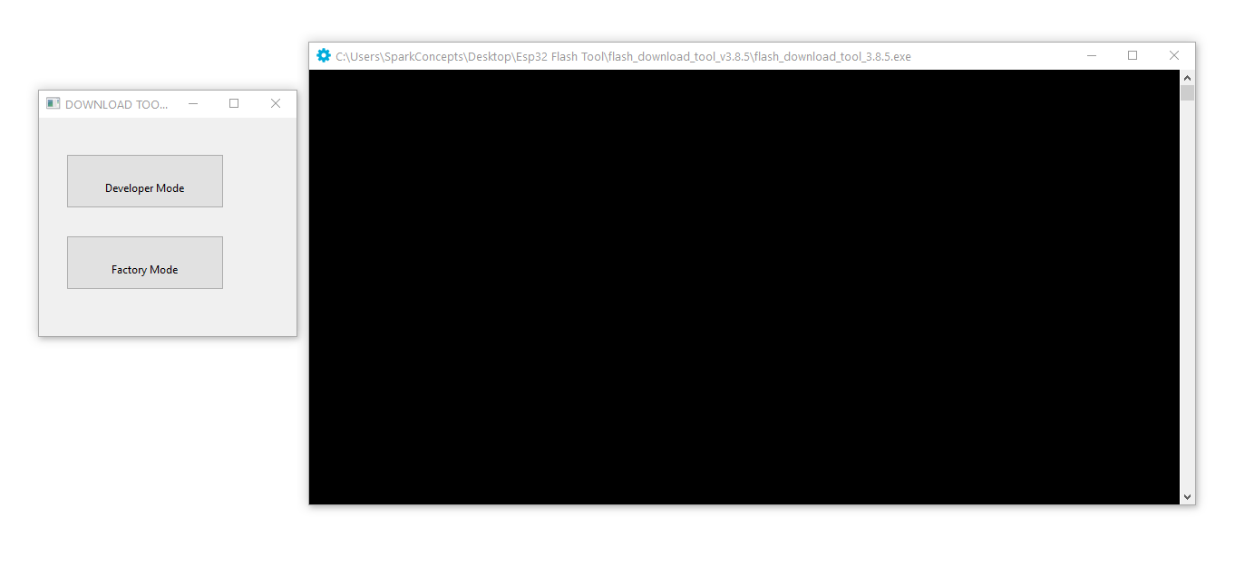

1. Select “ESP32 DownloadTool”

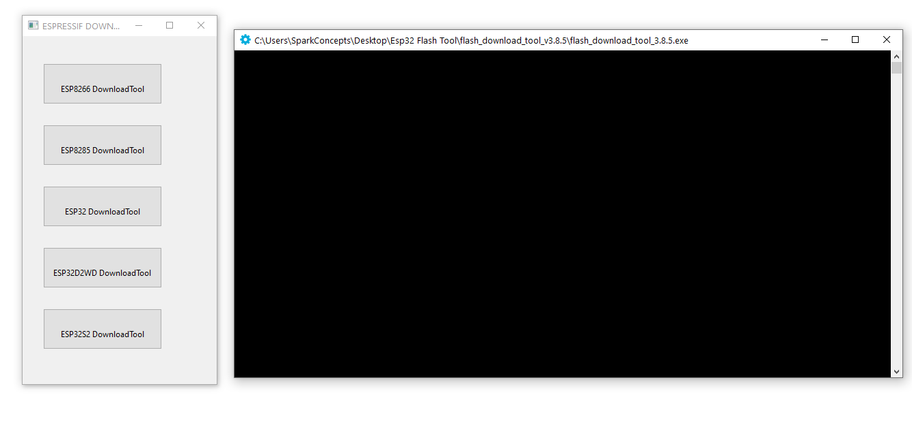

1. Select: 80MHz, QIO, and 32Mbit. Then Select the com port of the ESP, and BAUD: 921600

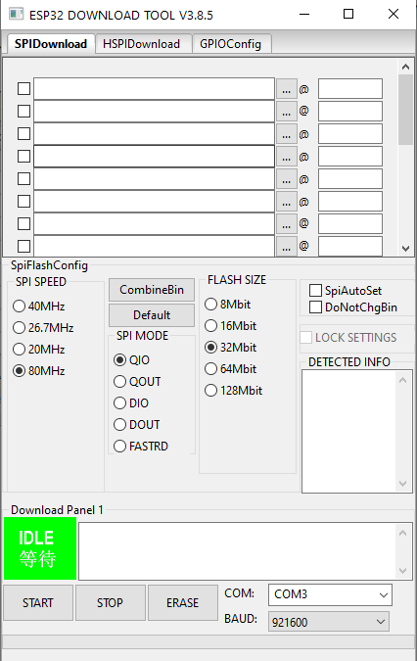

1. Click the button shown here below and select the xPV5xyyz.bin file. Click on the empty field to the right of the @ sign and write 0. Make sure the check box next to the file name is marked, otherwise the file won’t be programmed.

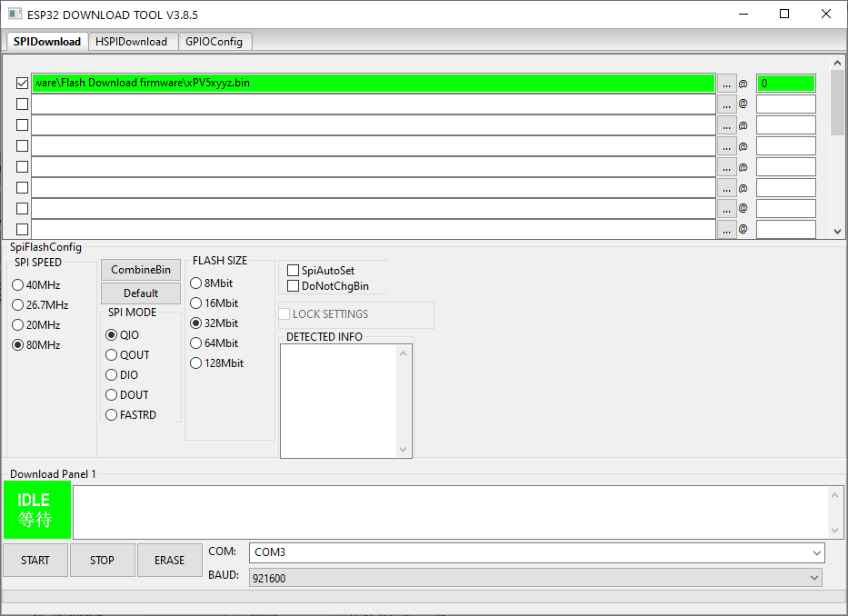

1. Press and hold the program button (SW2 on silkscreen) on the board module while you begin to upload the firmware with the START button. You can release the boot button once the green bar showing the upload status has appeared.

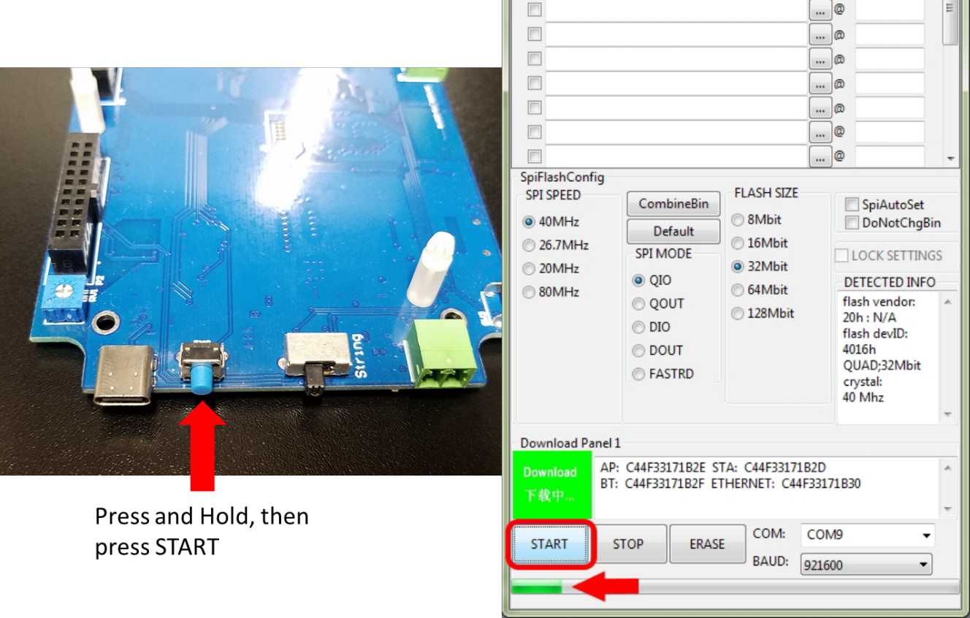

1. Wait until the firmware has been uploaded completely. If everything has gone smoothly, the word FINISH will appear on the green panel.



1. Repeat Steps 6 – 9 with the remaining boards to be programmed.